DEPTH FIRST SEARCH(DFS)

PROGRAM:
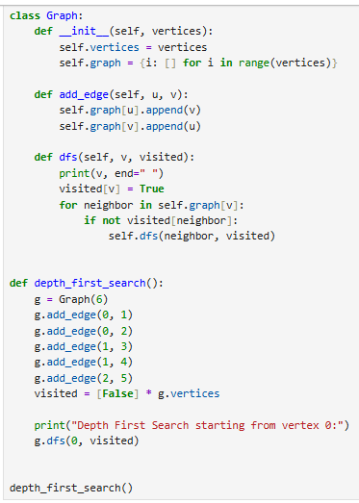
OUTPUT:
